CIRCUIT DIAGRAM:
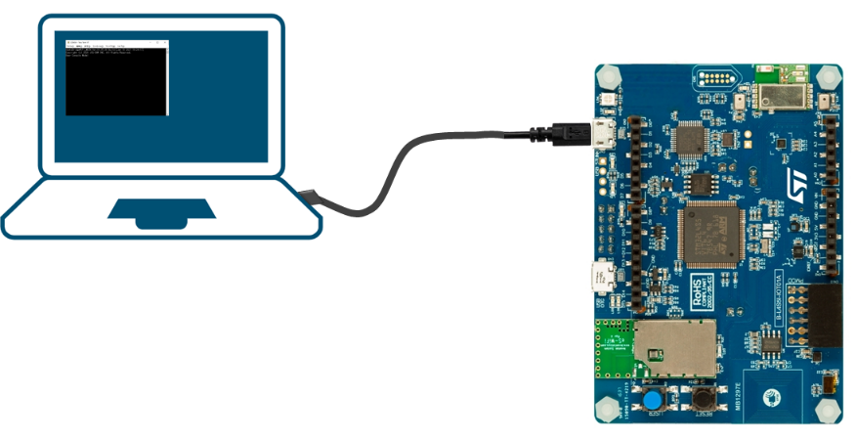
- STM32 Board: Represents the brain and central control.
- Power Supply: AC/DC adapter or USB cable used to provide power to the board.
- Software : Write the required code in the matlab.
- Connect Components: Use USB cable or barrel jack to connect the board & software containing system appropriately.

